COMPUTER NETWORKS LAB
TASK 2
ETHERNET FRAME INSPECTION
USING WIRESHARK
Packet details • MAC addresses • EtherType • IPv4 and IPv6

Name | Kasireddy Srihitha
Roll Number | 2520030153
Section | Sec - 7

1. AIM
To inspect Ethernet frames in the supplied Wireshark capture file, identify the source and destination MAC addresses, note the frame length and EtherType, and distinguish ARP, IPv4 and IPv6 frames.

2. SOFTWARE / INPUT REQUIRED
- Wireshark network protocol analyser.
- Capture file: CN_Lab1.pcapng.
- Display filter used: eth.

3. PROCEDURE
- Open Wireshark and load CN_Lab1.pcapng.
- Enter eth in the Display Filter bar and press Enter. A green filter bar indicates that the filter is valid.
- Locate the Packet List pane at the top of the Wireshark window. It contains the No., Time, Source, Destination, Protocol, Length and Info columns.
- Click a packet row in the Packet List pane to select it.
- In the Packet Details pane, expand Ethernet II using the arrow beside it.
- Read the Source, Destination and Type fields. Record the frame number and frame length.
- Repeat the inspection for the five selected packets.
- Open Statistics → Protocol Hierarchy to view the protocol distribution in the capture.

4. OBSERVATION TABLE
The following observations are taken from the packet details shown in the screenshots captured during the lab activity.
Frame | Length | Source MAC | Destination MAC | EtherType / Type
1 | 56 bytes | 4e:f6:89:3e:00:f1 | ff:ff:ff:ff:ff:ff | 0x0806 / ARP
2 | 355 bytes | 38:18:68:d2:99:d9 | 33:33:00:00:00:fb | 0x86DD / IPv6
3 | 348 bytes | b0:47:e9:ec:d5:ab | 01:00:5e:00:00:fb | 0x0800 / IPv4
4 | 56 bytes | 28:2e:89:72:c4:8a | ff:ff:ff:ff:ff:ff | 0x0806 / ARP
5 | 70 bytes | 10:5f:ad:9c:5c:ca | ff:ff:ff:ff:ff:ff | 0x0800 / IPv4
Observation: Frames 1 and 4 are ARP; Frame 2 is IPv6; Frames 3 and 5 are IPv4. ARP frames are not classified as IPv4 or IPv6 by the Ethernet Type field.

5.1 PACKET LIST WITH ETHERNET DISPLAY FILTER
The valid display filter eth is entered in the filter bar. The packet list shows the captured Ethernet traffic and the selected first frame.
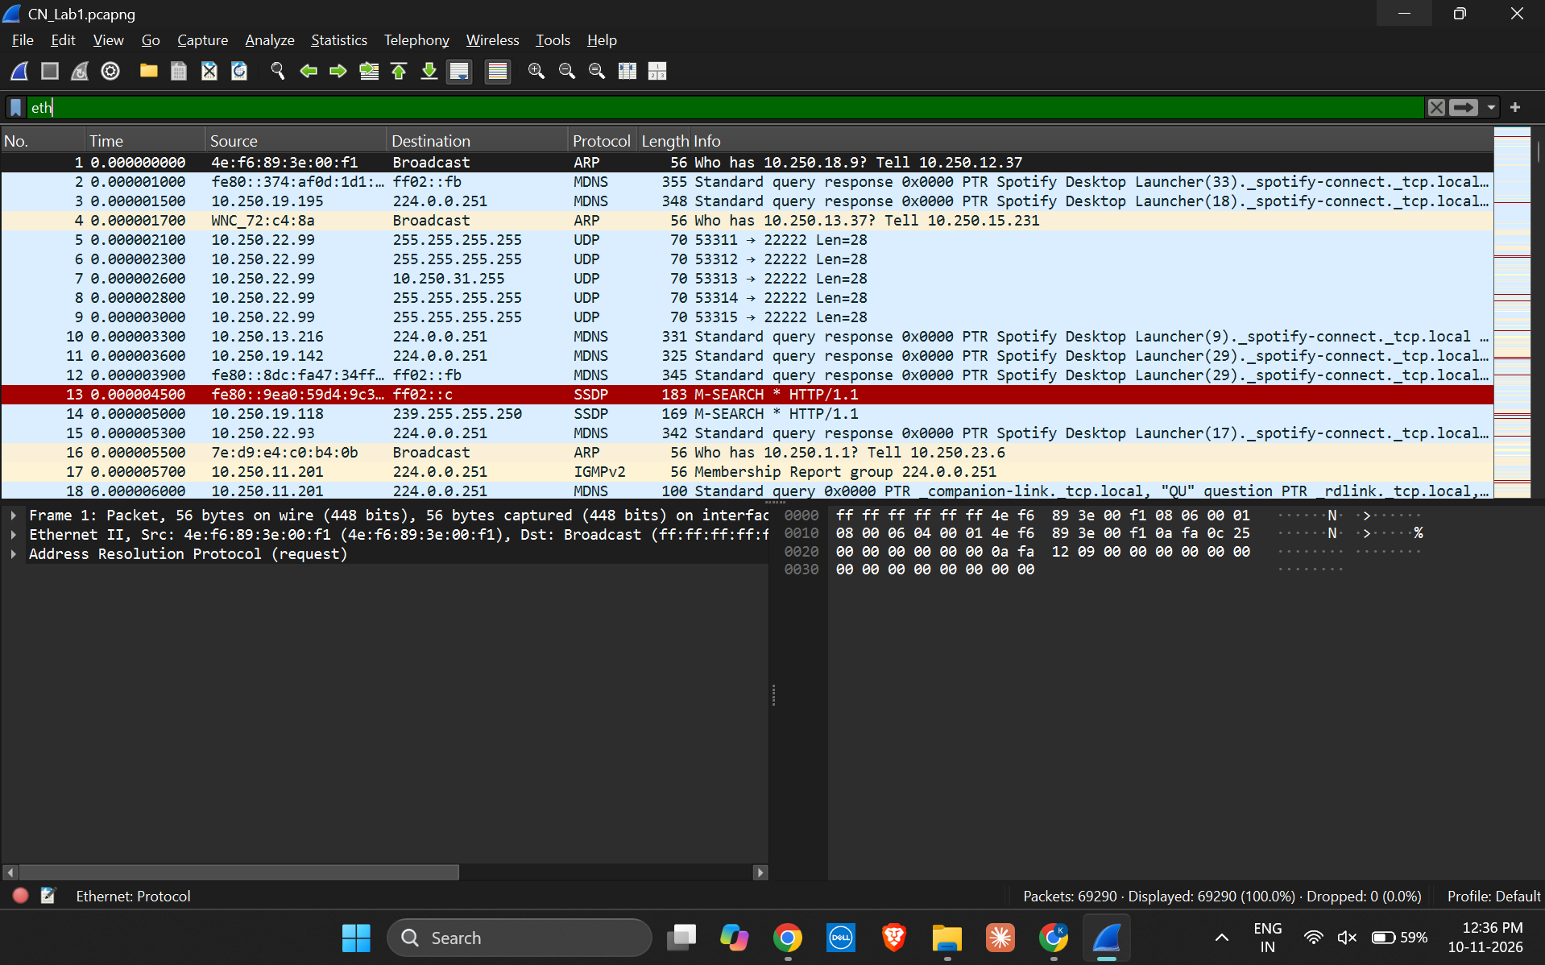

5.2 PACKET 1: ARP ETHERNET FRAME
Frame 1 is 56 bytes. Ethernet II shows source MAC 4e:f6:89:3e:00:f1, broadcast destination ff:ff:ff:ff:ff:ff, and Type ARP (0x0806).
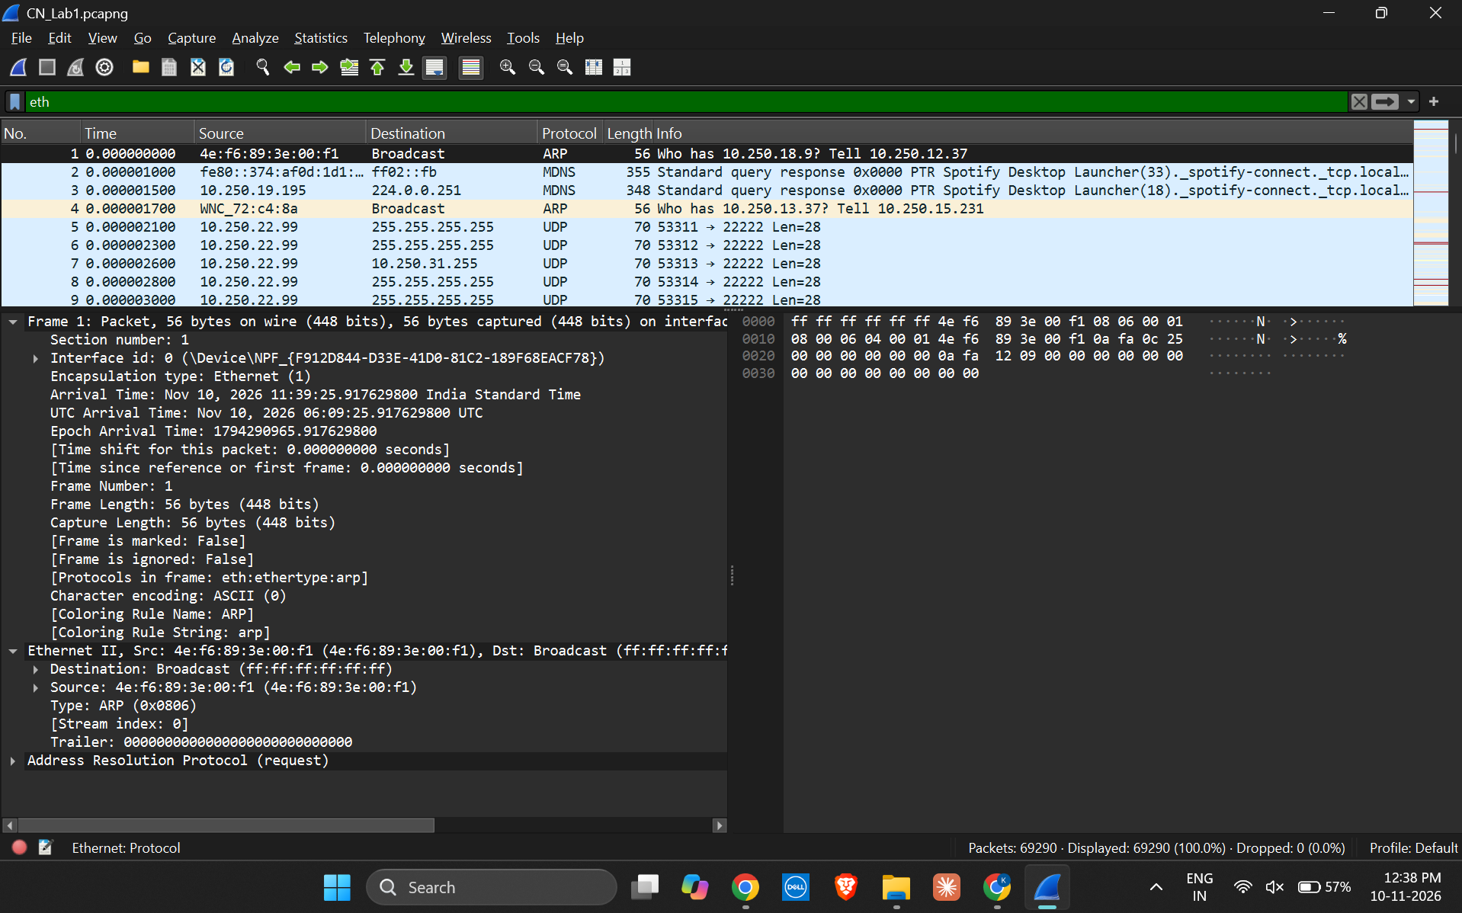

5.3 PACKET 2: IPV6 ETHERNET FRAME
Frame 2 is 355 bytes. Ethernet II shows source MAC 38:18:68:d2:99:d9, destination MAC 33:33:00:00:00:fb, and Type IPv6 (0x86DD).
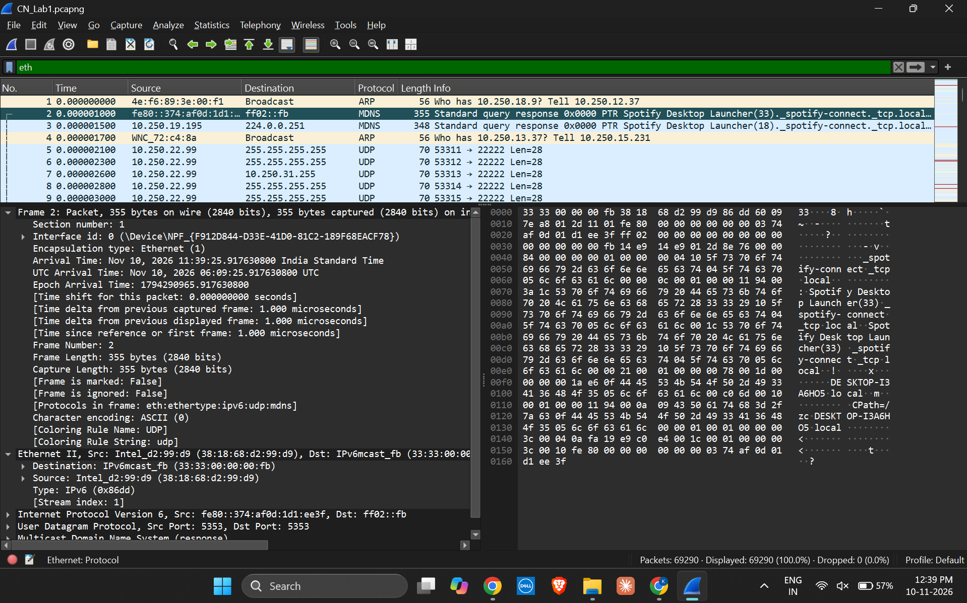

5.4 PACKET 3: IPV4 ETHERNET FRAME
Frame 3 is 348 bytes. Ethernet II shows source MAC b0:47:e9:ec:d5:ab, destination MAC 01:00:5e:00:00:fb, and Type IPv4 (0x0800).
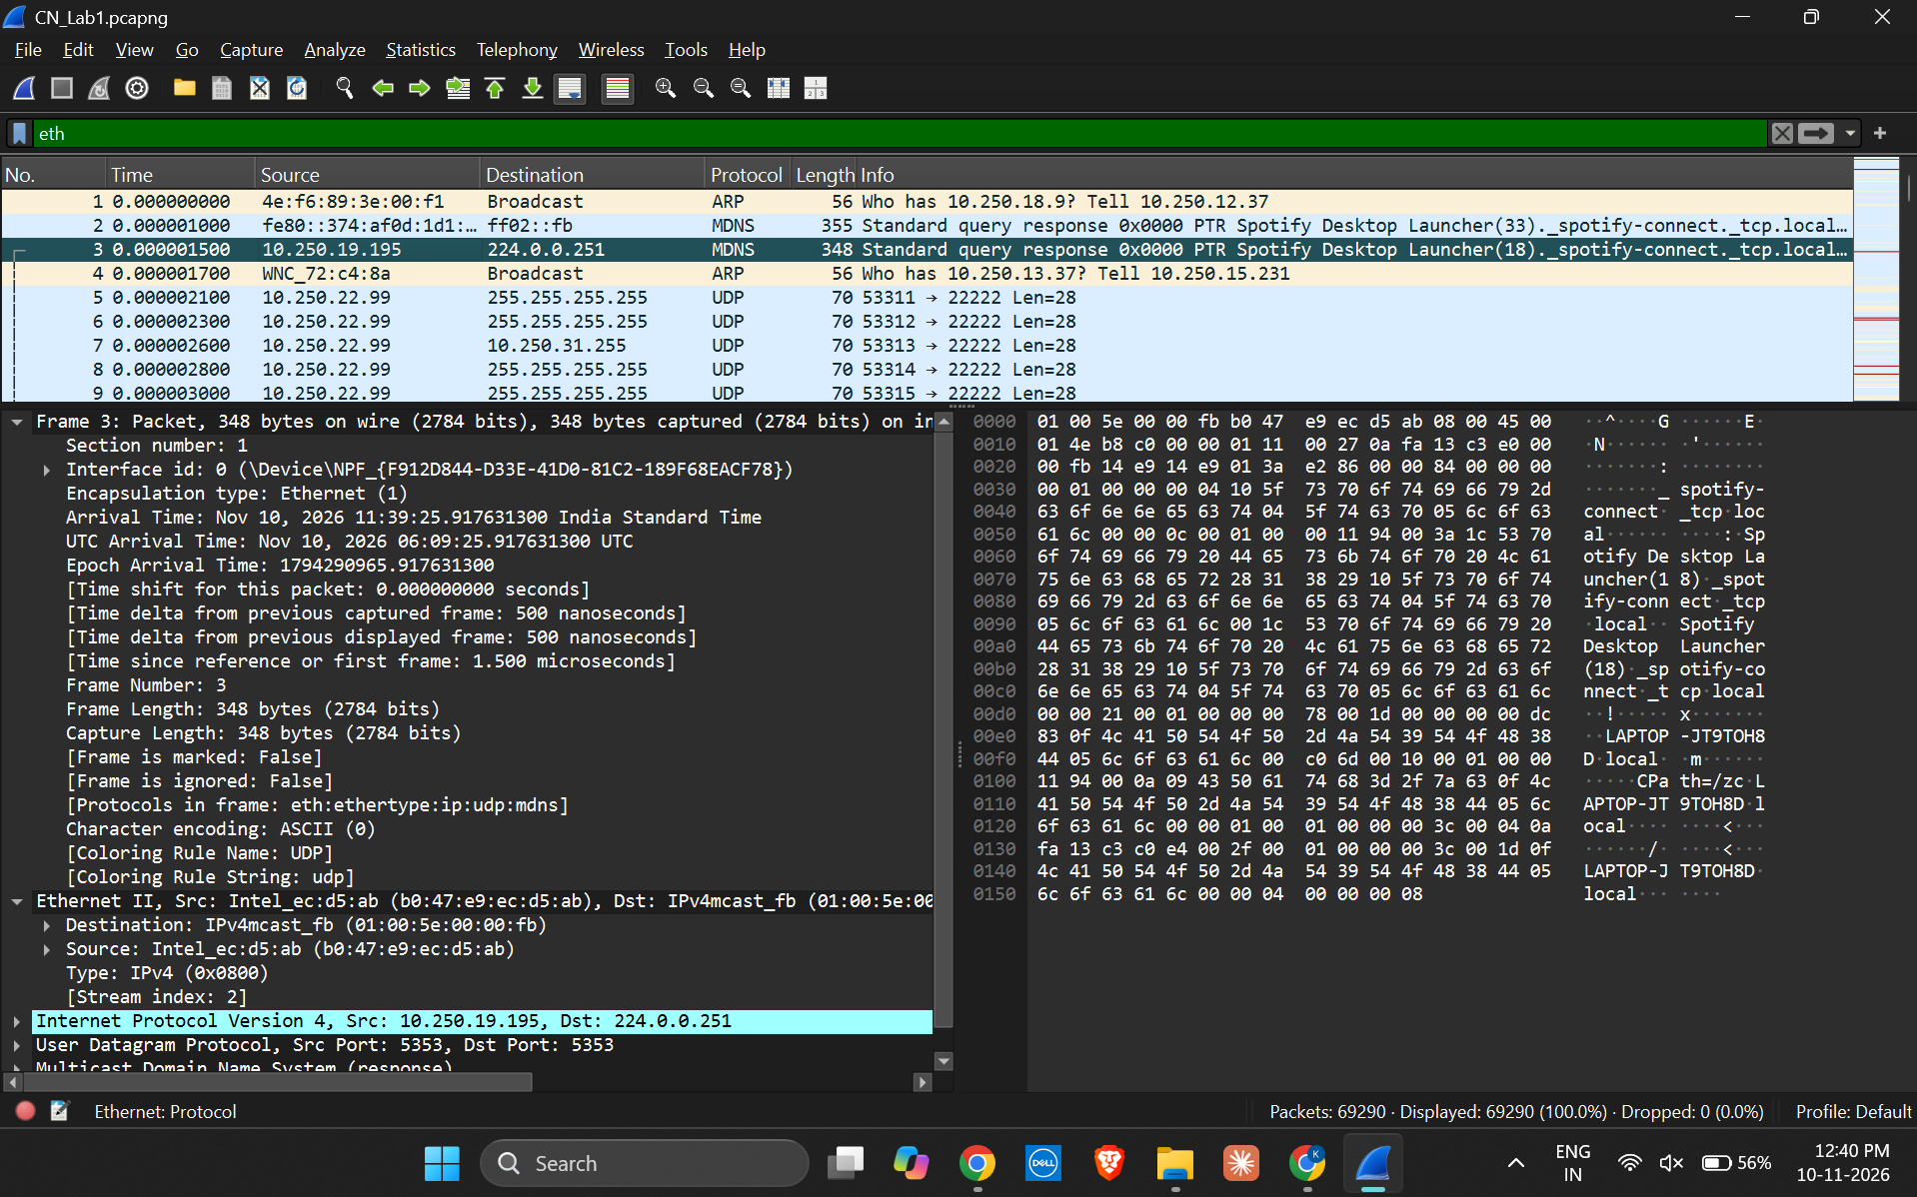

5.5 PACKET 4: ARP ETHERNET FRAME
Frame 4 is 56 bytes. Ethernet II shows source MAC 28:2e:89:72:c4:8a, broadcast destination ff:ff:ff:ff:ff:ff, and Type ARP (0x0806).
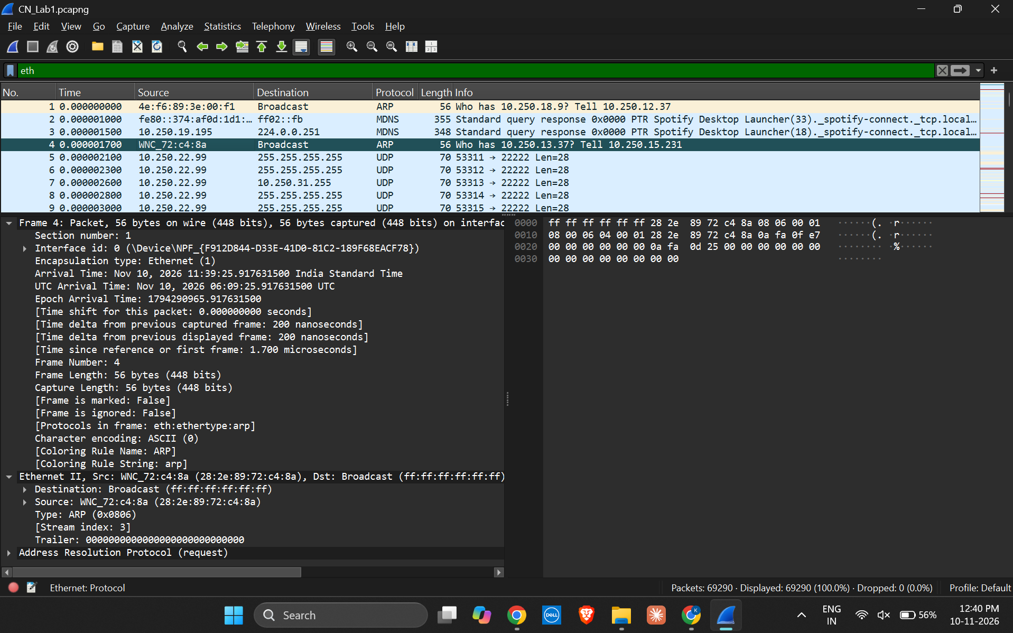

5.6 PACKET 5: IPV4 ETHERNET FRAME
Frame 5 is 70 bytes. Ethernet II shows source MAC 10:5f:ad:9c:5c:ca, broadcast destination ff:ff:ff:ff:ff:ff, and Type IPv4 (0x0800).
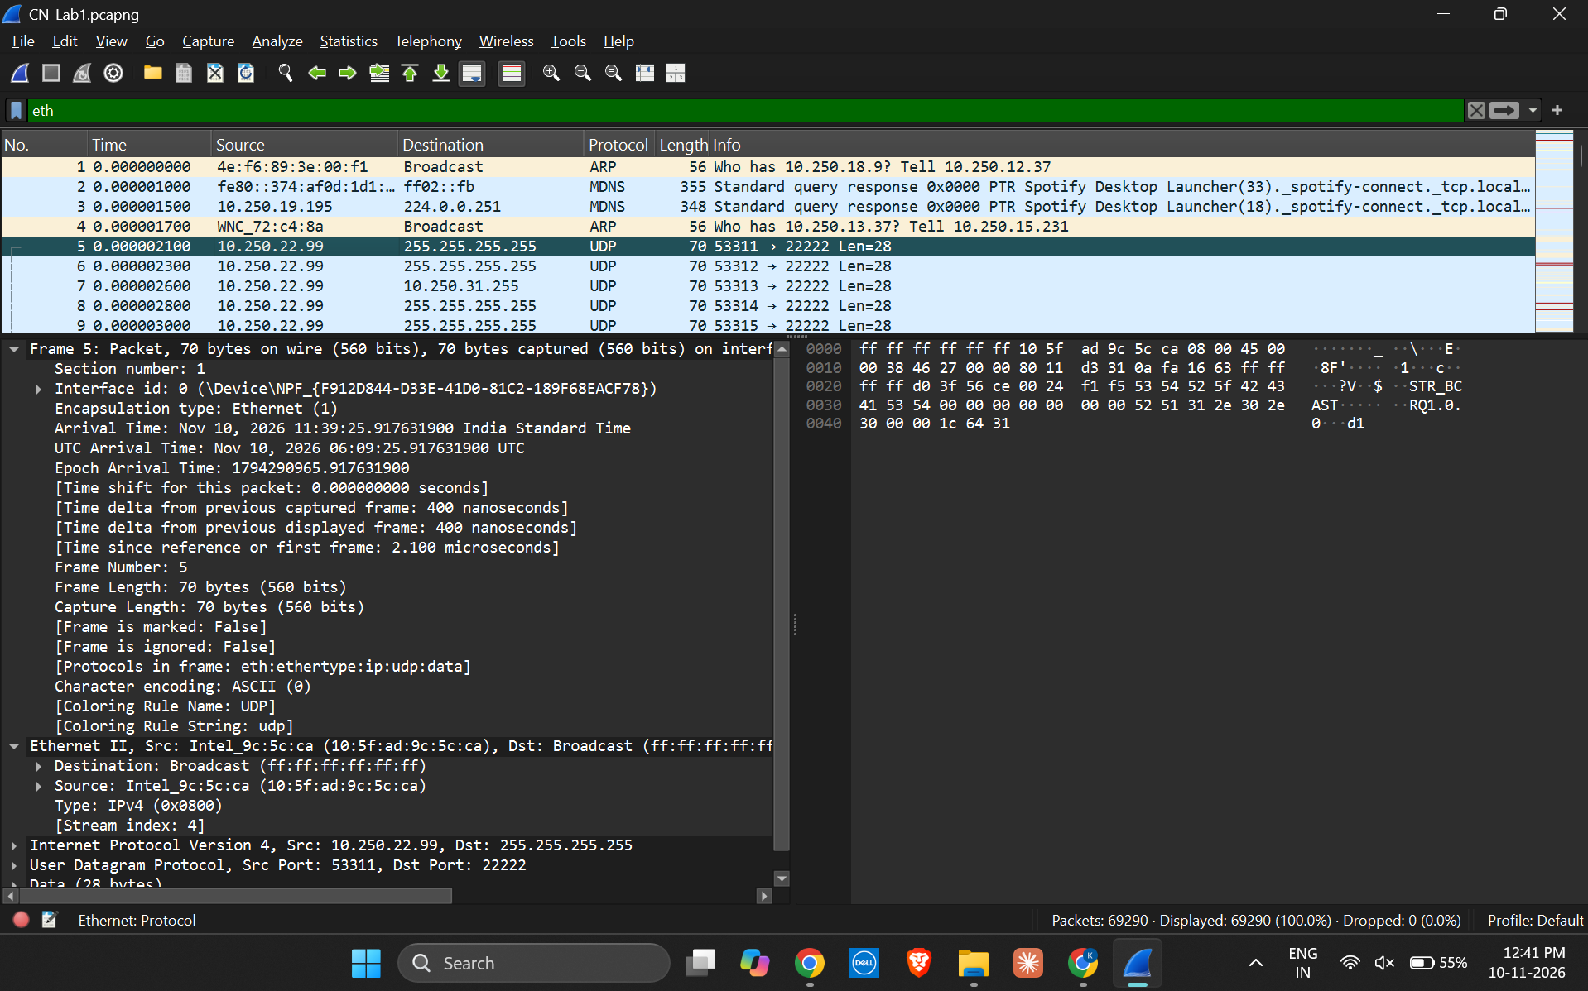

5.7 PROTOCOL HIERARCHY STATISTICS
The Protocol Hierarchy window summarizes the protocols and packet counts in the capture. The display filter eth is shown at the bottom of the statistics window.
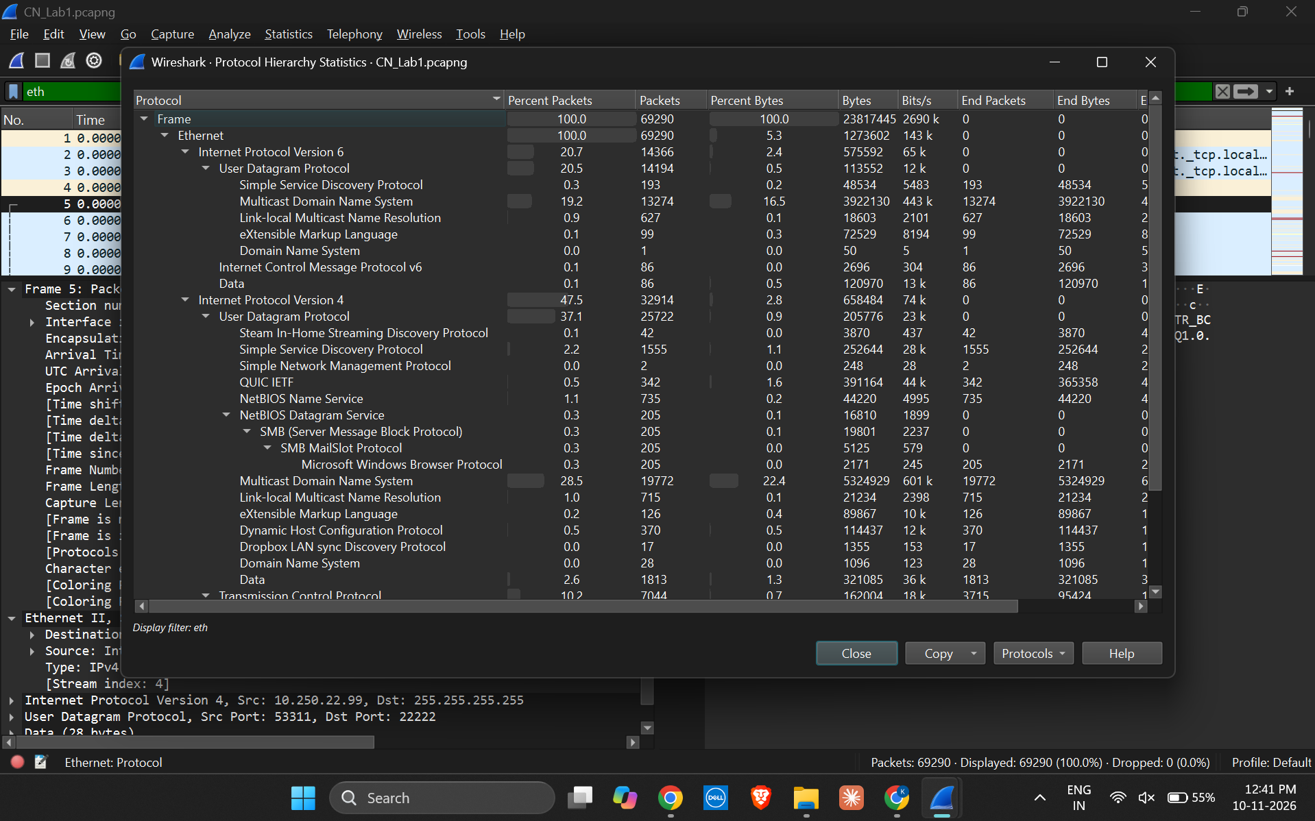

6. RESULT
Five Ethernet frames were inspected in Wireshark. Their frame lengths, source and destination MAC addresses, and EtherType values were recorded. The selected frames include two ARP frames, one IPv6 frame and two IPv4 frames.

7. CONCLUSION
The activity demonstrated how to inspect the Ethernet II header in Wireshark and use the EtherType field to identify the protocol carried by an Ethernet frame. The packet details also showed broadcast and multicast destination MAC addressing in the captured traffic.

8. FINAL CHECK
- Fill in the student name, roll number, section and date on the cover page.
- Check that all seven screenshots are visible and readable in the document.
- Save or export the completed report as required by the lab instructor.
- Keep the original CN_Lab1.pcapng file if the instructor requires the capture file along with the report.

